CSE211 Web Programming, Fall Semester 24/25

Assignment #1: Websites conceptual Design and mock-u

ID: 222100264, Name: Alhassan Muhamed Abdulmonem Muhamed

**2.3.1. Part 1: research**

**1-The defining characteristics of Web 2.0, 3.0 & 4.0**

wikipedia - According to Best, the characteristics of Web 2.0 are

* Rich user experience
* User participation
* Dynamic content
* Metadata
* Web standards
* Scalability

Further characteristics, such as openness, freedom, and collective intelligence by way of user participation, can also be viewed as essential attributes of Web 2.0.

___________________________________________________

bbvb.ch - Web 3.0 is the most current type of internet, whose main characteristics are democratization and based on semantic web technology.

___________________________________________________

techopedia - Web4, also known as the symbiotic web, is the fourth generation of the World Wide Web. It’s a decentralized, intelligent, and personalized version of the web built with emerging technologies, including blockchain, artificial intelligence (AI), and peer-to-peer (P2P) networks to give users greater control over how data is shared and accessed.

___________________________________________________________________

**2-Key features of Web 2.0 and how it empowers the power of networks**

Wikipedia - The key features of Web 2.0 include

* Folksonomy
* Rich user experience
* User participation
* Software as a service
* Mass participation

crowleymediagroup - With Web 2.0, the internet has transformed into an interactive and dynamic space where users can actively engage with content. “Web 2.0 empowers individuals to actively participate, collaborate, and share in the online world, shaping the internet into a more interactive and user-driven platform.

___________________________________________________________________

**3-Key features of Web 3.0 and how it empowers the meaning of data and knowledge connections**

spiderwort - The key features of web 3.0 technology include

* The use of blockchain and crypto
* Ubiquitous connectivity and IoT support
* Foundations in semantic web infrastructure
* Reliance on artificial intelligence (AI)
* Decentralization
* 3D and spatial-experienced UX
* Supporting the metaverse
* Redefined data ownership

coinmetro - Web 3.0, also known as the Semantic Web, focuses on machine-readable data and meaningful connections. It employs metadata, ontologies, and taxonomies to enable intelligent systems to understand and interpret information accurately.

___________________________________________________________________

**4-Key features of Web 4.0 and how it empowers the intelligence connections**

strivemindz - Key features of Web 4.0 include

* Artificial Intelligence (AI
* Big Data Utilization
* Software Agents
* Advanced Web Technologies

timesofindia.indiatimes - Web 4.0 services will enable the seamless integration of hardware, software, and data. Through these services, users will be able to connect to a wide variety of data sources, process that data in real-time, and generate insights for informed decision-making.

___________________________________________________________________

**5-Importance of collective intelligence, social networking, social media and social bookmarking**

marketing91 - **Collective intelligence** is widely recognized as a key factor in solving complex problems using human intellect via mass collaboration. This is because collective intelligence allows for the pooling of diverse human skills and knowledge, which is essential for tackling complex problems and effective group problem-solving.

___________________________________________________

indeed- **Social networking** continues to play an important role in business and individual careers. Here are some reasons social networking remains important:

* It connects people and businesses
* It helps businesses create advertisements
* It allows people to share information
* It facilitates instant communication

___________________________________________________

simplilearn- **Social media** - if used intelligently - can bring in loads of success. Since it is the best form of direct contact with the target audience, these platforms have what it takes to make anyone's life better. To understand this better, here are a few aspects that reflect the importance of social media in today's world.

* Staying Connected with the People
* Staying Opinionated
* Entertainment
* Share information

___________________________________________________

infront - **Social** **bookmarking** is an effective way to build your online presence. When you add social bookmarks to the web it helps search engines understand your site

**___________________________________________________________________**

**6- How these technologies empower the current and feature business plans**

**metyis - Collective intelligence could and should be a cornerstone to finding innovative and suitable solutions for businesses.**

**Concretely collective intelligence could be used for:**

* **Productivity**
* **Strategic Planning**
* **Innovation and product development**
* **Employee Engagement**
* **Customer Feedback**

___________________________________________________

**forbes - Social media** marketing strategies typically include creating engaging and shareable content, leveraging influencer marketing, running **social media** advertising campaigns, and using **social media** analytics to track and measure performance.

___________________________________________________________________

**2.3.2. Part 2: website planning**

1-To provide a platform to users so they can access a library of movies and series to watch it.

2-To generate profits

3-For teenager, adults and elderly

4-

5- Arabic and English movies and series\

6-High video quality, No mid-view ads and Content diversity

7-Clear menu, Search functionality, Minimalistic design and Multiple quality options

8- Simple interface, making it easy for users to navigate and find what they're looking for and buttons, icons, and menus are clearly labelled, making it easy to understand their purpose.

9-

10- He will go to the

11-

12- Add TV shows, add more translate to movies and series

13- Shahid & Netflix, because they use the same method and functions that I want to make in my website

14- a. To have 100,000 clients.

b. Movies, Series, Search bar, Sign in, Sign up, English movies, Arabic movies, English series, Arabic series

c. **Home** **Page** (logo, website name, navigation (movies, series, search bar, sign in), picture & name of random movies

**Movies** (picture & name for only movies)

**Series** (picture & name for only series)

**Search** **bar**

**Sign** **In** (username, password, forgot password, sign in, sign up)

**Sign** **Up** (First name, Last name, Email address, password, confirm password)

**English** **movies** (Action Movies (picture & name), Comedy movies (picture & name)

**Arabic** **movies** (Action Movies (picture & name), Comedy movies (picture & name)

**English** **series** (Action Movies (picture & name), Comedy movies (picture & name)

**Arabic** **series** (Action series (picture & name), Comedy series (picture & name)

d. Feature Requests: Users can submit suggestions for new features or improvements to the platform.

e.

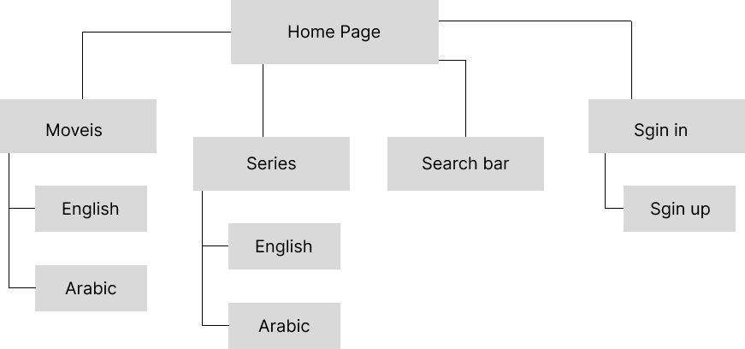

f. **Home Page**

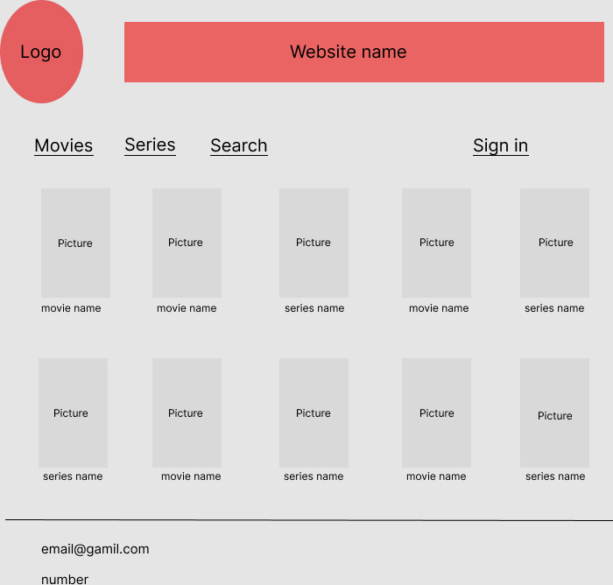

**Movies**

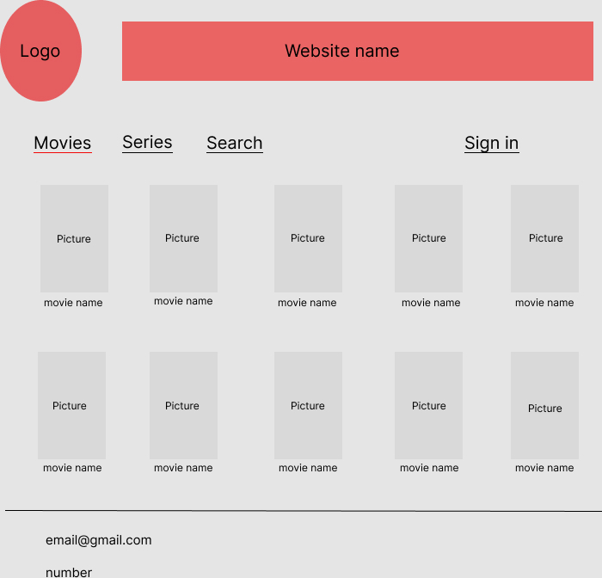

Series

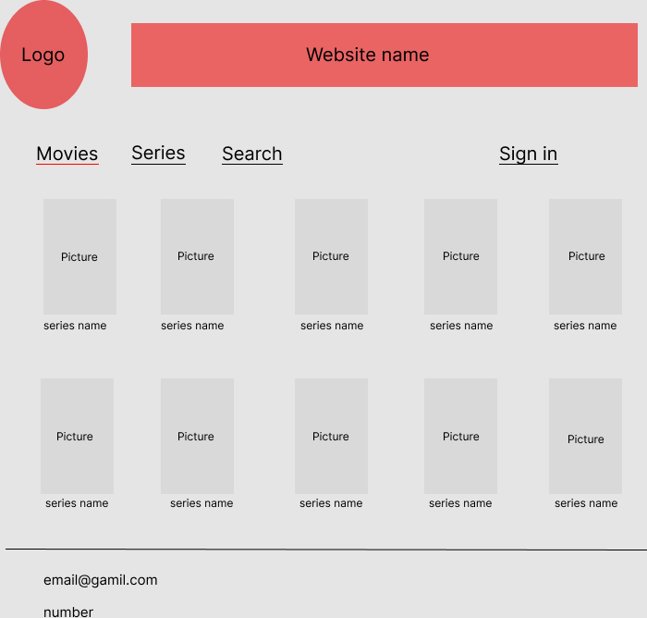

Search bar

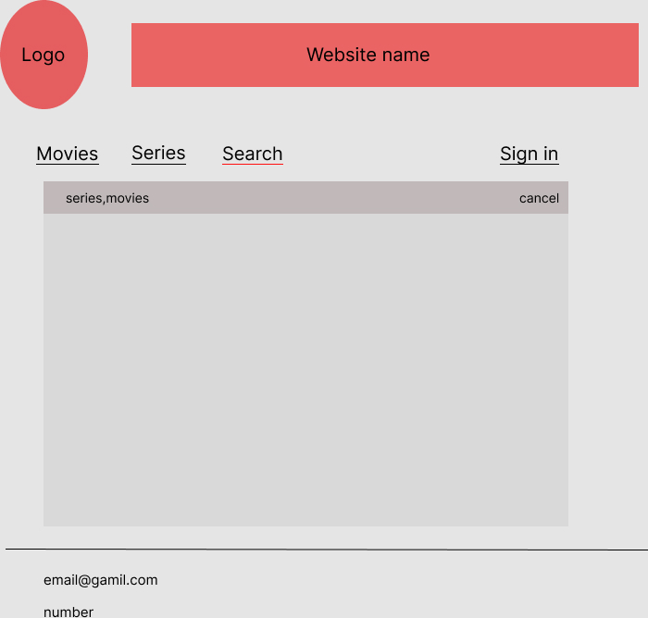

**English Movies**

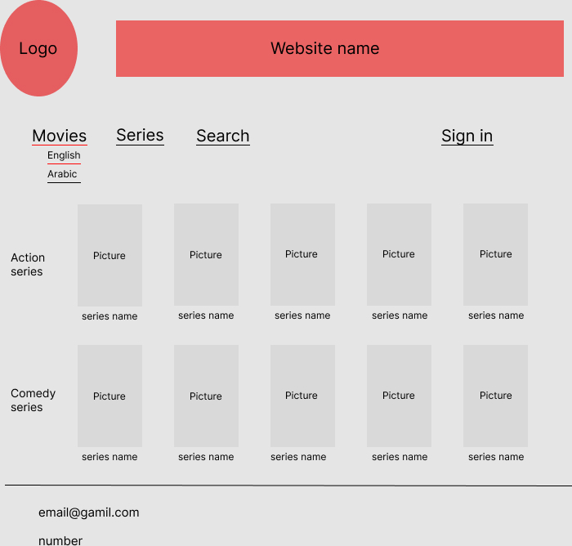

**Arabic Movies**

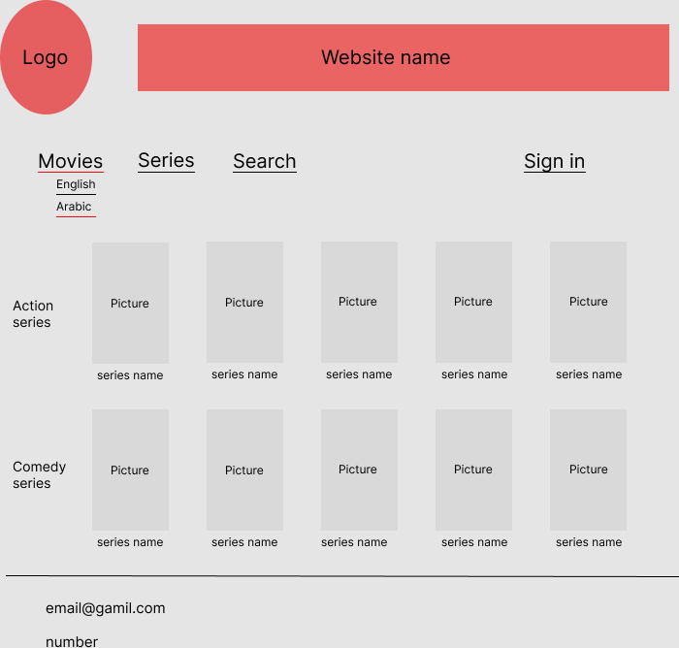

**English Series**

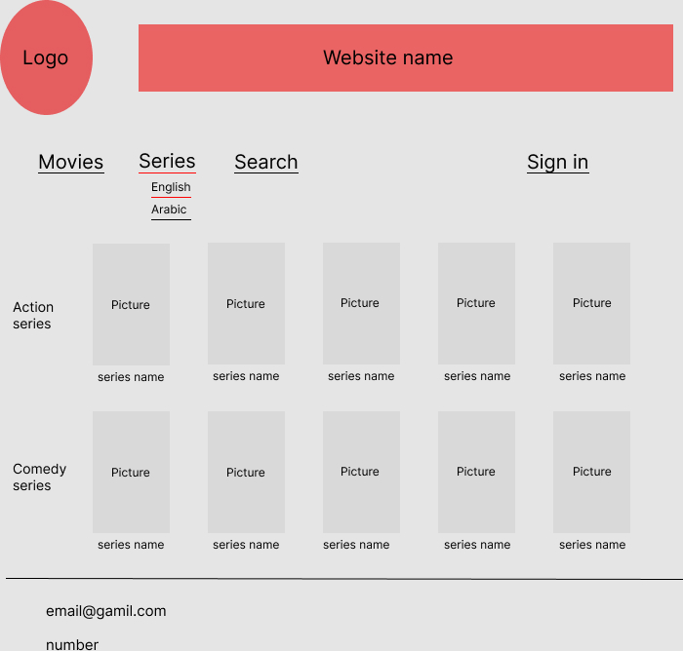

**Arabic Series**

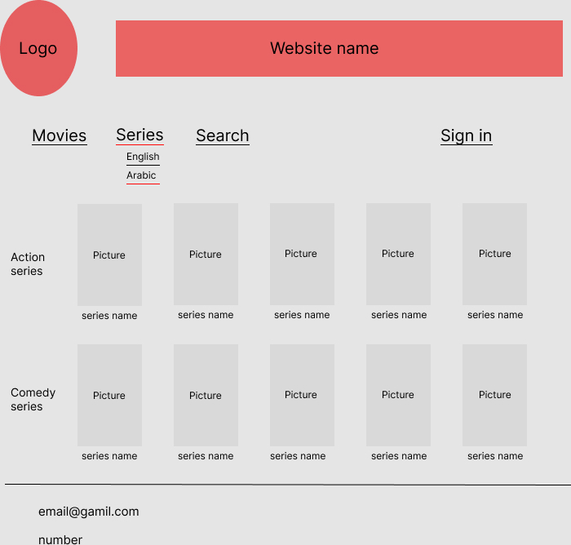

**Sign in**

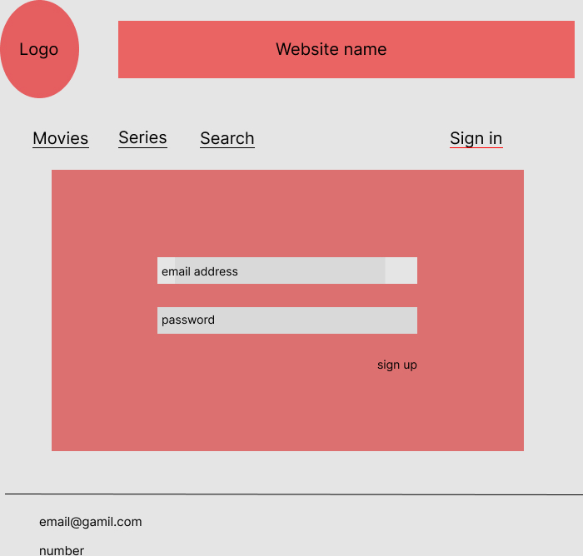

**Sign up**

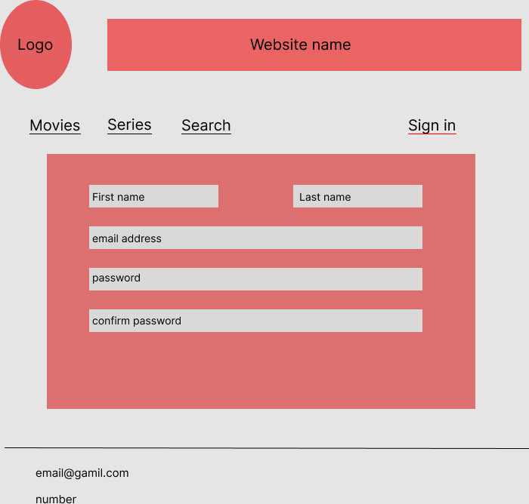

___________________________________________________________________

**2.3.3. Part 2: website design**

**[A]**

1- By Minimalist Design and Simple Colour Palette

2- By using simple icons that can be recognized for common actions

3- Maintain consistent spacing between element

4- By using a large, high-quality image to draw attention

5- By using consistent typography, colour palette and iconography throughout the website

6- By using clear headings to divide content into distinct sections

7- By placing related elements close together

8- Smooth scrolling transitions between sections

9- Animated Elements and Interactive Elements

10- Align elements horizontally and vertically to create a sense of order

11- Applying consistent styling to similar elements in movie posters, episode titles

12- Make the website easy to navigate with clear labels and intuitive interactions